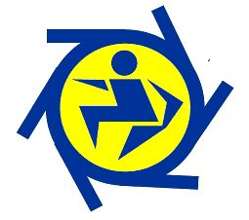
Centenary Little Athletics Centre
Parent Participation Refund form

I, ___________________________ parent / carer of _____________________________:
- Seek a refund of $75 of the parent participation levy
or
- Agree to donate the parent participation levy back to Centenary Little Athletics Centre
(circle your choice (either a or b)).
Conditions for refund of Parent Participation Levy are as follows:
- At least one parent / carer volunteers at a minimum of 60% of club meets (this is approximately 9 club meets due to rained out club meets) throughout the season. This can include any of the following:
- Assisted for the duration of the evening, including set up or pack away where applicable
- Assisted at regional carnivals or championships
- Assisted at the western suburbs meet
Assisted at any other CLAC events IE Working bee, sign on days, fete promotional events.
Refund will be made via payment of EFT to your Bank account as details below:
Please complete the following details for your refund:
BSB Number: | Account Name: |  |  |  | Account Number:
Personal details will be kept confidential and will not be used for any other purpose other than to refund the parent participation fee.
CLAC use only
60% parent participation approved |  |  | Please circle Yes or No
 |  |  | Yes |  |  | No
Amount Refunded/Donated: |  |  |  | Refund/Donated Date:
Approved by: |  |  |  | CLAC position:

